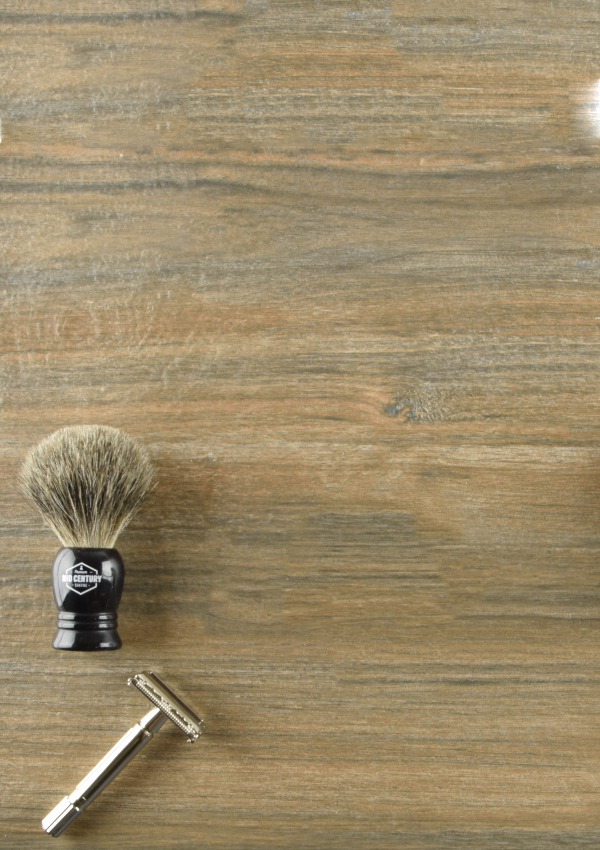–

MARKETING PLAN

Premium Mid-Century Shaving

Amol Kolhe | Ekaterina Marchenko | Indraraj Naidu | Sneha Thanasekaran

Contents

Executive Summary 3

Market Opportunity 4

Strategic Goals and Marketing Objectives 5

Mission Statement 5

Strategic Plans 6

Marketing metrics benchmarks 6

The Company 7

Company Orientation 7

SBUs/Portfolio 8

Differential Advantage 8

DA Matrix 9

The Customer 9

The Context 11

The Competition 13

Industry attractiveness, entry requirements 13

Differential advantage for main rivals 15

The Collaborators 15

SUMMARY OF Five-CS 16

SWOT Analysis 16

Marketing Research 18

Market Concentration Decisions 21

Market segmentation 21

Targeting 22

Marketing Mix Decisions 25

Products 25

New product development 26

Price 27

Break Even Value 27

Promotion 28

Placement 30

Conclusion 31

Budgets and Forecasts 32

APPENDIX 32

# Executive Summary

Premium Mid-Century Shaving is a Niche Company that focuses on bringing back the traditional wet shave and introduce it as an art to the modern, busy men of today. This vintage shaving company is born out of love for wet-shaving. The business model is an online eCommerce Store that caters mainly to the US population. Based in St. Louis, Missouri, the main channel of business for the company would be amazon. The products are promoted/marketed through amazon.com and Facebook marketplace. With the changing lifestyle where shaving is becoming a mundane activity, Mid-Century Shaving focuses on reintroducing shaving as a relaxed, enjoyable activity to the modern, working professional.

The products sold by the shaving company includes safety razor, badger brush, scuttle and stand for the shaving kit. Their recent addition to the product line is an inhouse made scented shaving cream. MCS’s main customer segment are professional men between the age group 18-45, who likes to look sharp with a clean shave. Based on market research, there will be a steady growth in the United States in the interest in male grooming and shaving over the next 5 years, driven by the younger population.

With this recent increase of men interested in personal grooming and clean shaves, there is a tremendous opportunity to re-introduce the classic form of shaving into the market. The main reason why wet shaving is not famous is because there is a learning curve with safety razors and it can be overwhelming. MCS wants to change that mindset and introduce the benefits of wet shaving and educate men on how simple, cost effective it can be. Recent research shows that the replacement cartridges with new technological improvements are expensive and most men look for simple shaving solutions. While there is a rise in interest for these vintage shaving kits, MCS is the only brand that focuses on educating the customers about wet shaving, benefits and value of the and is beginner friendly.

Based on our analysis and the market research, MCS is projecting a sales of $149950 next year with the marketing budget of 16% that will focus on gaining 3500 customers and increasing the brand awareness by 40%.

# Market Opportunity

On an average a man shaves 20,000 times in his lifetime. It is estimated that at least 90% of men shave every other day. The market is dominated by electric and cartridge razors. There is a growing dislike for electric razors as they do not provide a closest possible shave and cartridge razors needs replacements that are not easy on the pocket. This has made the customers turn back to the old school, classic traditional shave using safety razors. The main advantage of using a safety razor and wet shaving is it provides a close, effective shave with no suffering from skin irritation and hair ingrowth - the most common issue faced by men.

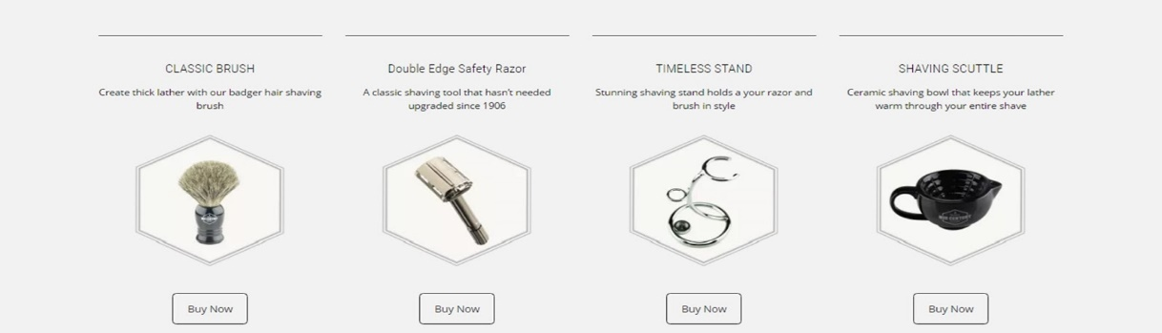

While the focus is on safety razors and promoting wet shaving for men, another market opportunity exists for the company to incorporate accessories of shaving such as aftershave, moisturizer and blades. Although the scope is restricted to men currently, there is a foreseeable future to expand the brand to cater to feminine needs. There is an anticipated increase in the market for women who would like to switch to safety razors over other forms of hair removal such as disposable razors(most common among women), waxing and laser removal. Despite growing technology, there is a demand for simple and effective shaving solutions that is practical and worthwhile. MCS can harness this demand and can capture the market. There is a potential scope to open retail store as well.

# Strategic Goals and Marketing Objectives

## Mission Statement

Mid Century Shaving currently focuses on raising awareness of wet shaving and promoting safety razors for effective, close shave. While electric razors and cartridge razors hold most of the market share, there is an increase in interest on safety razors. MCS believes this is due to the ever-increasing price and multiple discomfort that has convinced men to switch to the safety razor. Thus, MCS’s strategy will be on providing value, based on price and benefits of wet shaving over the other popular shaving options.

## Strategic Plans

MCS focuses on men with good grooming habits and a professional attitude. The point of differentiation is that the brand stands out in terms of its main product, the safety razor that is a lifetime buy that lasts for at least 10 years. It is cost effective, made of premium quality and gives the closest shave possible. The brand also focuses on educating the target population on the process involved in wet shaving and its advantages, thereby helping the transition of beginners to wet shave. MCS focuses mainly on online sales through amazon and hence the main channel of marketing is online ads. The brand must also focus on maintaining a positive reputation across the online platforms through reviews and ratings.

As the brand is an online eCommerce store, MCS will continue focus on online sales through its major collaborator, amazon.com. Since amazon is a vast marketplace, the market size is based on professional men who work in corporates and have an annual income between $50,000 to $200,000. The primary marketing campaign will be targeting the men with professional attitude who wants a clean, sharp look.

## Marketing metrics benchmarks

**Short-Term Goals**

* Increase the number of click throughs to the webpage by 100% that is currently at 6%
* Increase the number of rating published on amazon (230) to 400 by encouraging buyers to give feedback
* Reduce the bounce rate (30%) by at least 50% by enhancing the user experience of the page.
* Increase the number of visitors through organic search to the webpage by 20%

**Long-Term Goals**

* The brand plans on increasing the organic clicks by ranking in the 1st page of google search for selected keywords – Optimizing the content for webpage
* Penetrate the market to gain at least 40% of the market share on wet shaving products
* Make mcshaving.com as the primary channel to sell products thereby increasing the brand awareness by 60%
* Have a maximum conversion rate of visitors to users at 80% thereby increasing revenue

# The Company

## Company Orientation

MCS is an online, eCommerce store that is based on the product concept. It offers premium quality products at a medium price. The focus is given to the aesthetic appeal of the products as well. Consumers tend to favor the product that is of great quality and simple features when it comes to shaving supplies as opposed to innovation and multiple features.

## SBUs/Portfolio

MCS focuses on main SBUs.

* The Marketing unit that takes care of the brand reputation and awareness. The main objective is to maximize the revenue generated through ads. The system comprises of a team of 3 – the web developer, designer and the manager. Together they develop the marketing strategy that aligns with the company’s objective and takes care of the customer relationship as well.
* The inventory management unit that takes care of the logistics of shipping and inventory. Being an online store, the cost of maintenance dedicated to the inventory management is less. The whole unit is managed by the manager and the owner of the company.

## Differential Advantage

Analysing the customer experience with shaving, it is evident from the survey that more than 60% of the men in United States are frustrated with their current shaving razors. The replacement cartridges are expensive, they lead to ingrown hair and they leave the skin dry and rough.

* MCS safety razor provides the closest possible shave that leaves the skin smooth. Closest shave results in fewer shaves per week and smooth skin is an additional benefit.
* Multiple blade razors give rise to ingrown hair which results in skin spots. Because of the single blade system, there are no multiple passes. This can avoid ingrown hairs.
* Being an online product, they are available for purchase at the consumer’s convenient time and they get fast deliveries to their doorstep.
* MCS is the only brand that provides “How-To” guides along with the razor purchase making it easier for beginners to get used to the vintage style shaving.
* A single razor last for a minimum of 10 years. The single blade is the only disposable element of the entire setup making the safety razor environment friendly.

### DA Matrix

|  |  |  |  |
| --- | --- | --- | --- |
|  | Online Shopping | Promotions | Premium Quality |
| Efficient Shaving Experience (close shave and smooth skin) | (1,1,1) | (1,1,1) | (1,1,1) |
| 100% Cashback (Monetary Benefit) | (1,1,1) | (1,1,1) |  |
| Beginner Friendly | (1,1,1) |  | (1,1,1) |
| Cost-Effectiveness | (1,0,0) |  | (1,1,0) |
| Fast Delivery and convenience | (1,0,0) |  |  |

## Value Proposition

Why get frustrated with the new technology shaving that changes every day and is expensive, while you can have a clean, smooth and relaxed shaving experience by adapting to the yesteryear grooming using safety razors and vintage wet shaving supplies.

The Customer

Three key questions

### 1.Who is the customer?

The statistics shows that most individuals start shaving when they are 12 and some

continue shaving into their 70’s and 80’s. It is estimated that about 94 million men currently shave in the United States. This significant amount justifies the growing trend

in shaving products. Increasing awareness in personal grooming among men has helped to boost the popularity of various shaving techniques. Through MCS, the customers who tend to care about having smooth skin and like/wants to try vintage shaving will be targeted

MCS will be looking at middle/upper middle-class men between 18 and 45, with an annual income range from $65,000 to $160,000 who are into personal grooming and looking for simple, cost-effective shaving solution. Nearly 65% of men said they preferred to be clean shaven because their partners preferred it, 15% said a smooth face made them feel younger and 10% said they had to be clean shaven for work.

### 2. What does the customer value?

For most individuals, male grooming is becoming a part of the day to day life. The main benefits that the customers desire are:

* Closest shave possible for smooth skin
* No cuts, burns or ingrown hair – very common problem
* Simple, efficient and easy
* Cost effective
* Soothing and relaxing shaving experience

### 3. How can we communicate with the customer?

The main point of contact with the customers is through the forum in amazon. MCS strives at answering customer queries and resolving issues as quickly as possible. Every positive review and a 5-star rating shows customer appreciation and increases the brand awareness. MCS marketing communication consists of ads through Facebook, Instagram and Google AdWords.

Estimated life time value

|  |  |  |  |  |
| --- | --- | --- | --- | --- |
|  | **Year 1** | **Year 2** | **Year 3** | **Year 4** |
| **Sales** | 13245 | 30288 | 45761 | 48883.28 |
| **Cost per unit** | 23.9 | 23.99 | 23.99 | 23.99 |
| **Total customers** | 554.1841004 | 1262.526053 | 1907.503126 | 2037.652355 |
| **Monthly customers** | 46.18200837 | 105.2105044 | 158.9585939 | 169.8043629 |
| **Revenue** | 13445 | 30712 | 47009 | 51620 |
| **Monthly Revenue** | 1120.416667 | 2559.333333 | 3917.416667 | 4301.666667 |
| **Montly Revenue per customer** | 24.2608909 | 24.32583465 | 24.64425843 | 25.33307503 |
| **Total cost of goods sold** | 14967 | 24700 | 41459 | 48524 |
| **Gross Margin (percentage)** | -11.32% | 19.58% | 11.81% | 6.00% |
| **Monthly gross margin (percentage)** | -11.32% | 19.58% | 11.81% | 6.00% |
| **Retention Rate** | 4.00% | 4.00% | 4.00% | 4.00% |
|  | -68.65949415 | 119.0470483 | 72.7390682 | 37.98488972 |
|  |  |  |  |  |
| **Estimated Lifetime Value** | **161.1** |  |  |  |

# The Context

## Context Details:

Shaving is a billion-dollar industry. The Daily Beast, a hip news site with 17 million viewers each month, states that shaving and hair-removal products represented a $4.13 billion market in the U.S. during the year 2013. The financiers are working themselves into a lather, as personal grooming is a huge business. Shaving will always be in great demand, as it is a necessity of every men in the planet. However, many brands such as Gillette, are seeing a decrease in sales due to the high prices of their razors despite investment is Research and Development. Simply put, many people won’t pay the high prices associated with razors as shaving is more a necessity than a luxury.

Shaving has evolved drastically since the invention of the first razor. The size, number of blades, and look have all changed the perception of shaving. All these changes provide the consumer with many options. Many experts believe shaving is a growing trend and will continue to grow in the coming years. In 2013, the shaving segment, which includes razors, blades and shaving cream, generated 3.6 billion in revenue. This makes up 8.6 percent of personal beauty sales.

## Economic Details

The market concentration in the shaving industry can be determined one of two ways. One method is to use the concentration ratio, which can be somewhat misleading. The preferred method is to use the HHI. This method takes each company's market share squared and totalling them. This will provide us with a number between 0 and 10,000. If one firm dominates the market, then the HHI will be 10,000. If the market has many firms and the market shares are evenly divided the HHI will approach 0. However, in this industry the HHI is 8,862, with Gillette dominating, while Schick/Wilkinson Sword and Bic follow suit as industry leaders. In the market of safety razors, west coast shaving dominates the market share followed by the art of shaving.

Cultural Details

The American culture is used to convenience and they like to have all the products easily accessible. MCS is a product which can be ordered online and can be replaced if the customer did not like it with 100% of their money back. People now a day like to buy premium products but due to the price they become reluctant. MCS provides the same premium and vintage looking products at a reasonable price.

Forecasted Demand

Market demand is a function of the context described above. In this case, demand is calculated just as a function of the population of United States who likes to have a clean shave. Excluded from the calculation is the specific population of who like to keep beard or use electric razors and trimmers; though they are still a target segment according to market research.

Potential number of buyers * Number of Razors sold * average price per product = Forecasted annual market demand.

**U.S population men who like clean shave* 12,270 Razor sold per year * $30 average price = forecasted demand**

**94,400 * 12,270 times per year * $30 average price = $62,844,140.00**

While currently the revenue generated by MCS is $51620, the brand is in a steady pace to acquire the maximum market share within the next 5 years.

# The Competition

Industry attractiveness, entry requirements

Shaving is now seen as more than a necessary hassle undertaken for looking smart for the office. It is a major part of personal grooming in the lifestyle of the modern man. Thus, there is always an inevitable growth in the market. The industry is saturated with safety razors that are from luxury brands to cheap, flimsy ones. There is enough rivalry between the brands to rank top on google search and create a differential advantage.

There is very little to no entry barrier for the wet shaving market, especially for an online store. The initial investment by MCS is around $11,000. However, MCS will stand out with contents dedicated to beginners in wet shaving. There is high threat of new entrants, but the brand is confident to penetrate the market in the next 5 years.

Direct Competition

The main companies that follow the same company model are: Maggard Razors, The Art Shaving, Gentleman Jon and Classic CS Shaving. Established over 5 years, they have captured the market share on wet shaving. MCS strives to understand their marketing concepts to expand successfully in the market.

Indirect Competition

The main indirect competitor is companies who provide products for modern shaving: cartridge razors and electric razors. Gillette offers a disposable and replacement razor cartridge that is readily available in any drugstore. The dollar shave club that is a subscription-based model uses the advantage of convenience to its advantage. Order and forget, the subscription will make sure you never have to worry about shaving supplies.

Beard grooming companies such as Beardsley and Maison Lambert that promotes growing facial hair can affect the trend of clean shave, which in turn will result in loss of revenue for MCS.

### Potential Competition

With the laser industry evolving as an effective hair removal solution, there is a foreseeable future where men could opt for laser hair removal.

## Differential advantage for main rivals

* MCS safety razors are made of premium quality stainless-steel that is strong and perfectly aligned as opposed to the flimsy, light weight and misaligned low-cost safety razors available in the market.
* For $22 the cheap cartridge razors can give 4 replacement cartridge that will last 4 weeks while for the same prize, the safety razors can fetch single blades that will last at least 18 weeks.
* All the products available in MCS is made in USA. There is no bulk import from countries like China and Korea where the products are mass-produced, and the quality is not assured.
* The traditional safety razors give an effective, simple and clean shave with a single blade. The design remains the same since 1908. It is not overcompensated with a few number of blades, unstable and constantly evolving technology along with pricey replacement cartridges.

# The Collaborators

The primary channel partner for MCS will be amazon. MCS has built a reputation in the platform with a 4.52-star rating and 152 positive reviews. It is the first point of contact to the customers. The razors are procured from American Cutting Edge, one of the top razor manufacturers in the USA. The main marketing channels will be through Facebook ads and google AdWords.

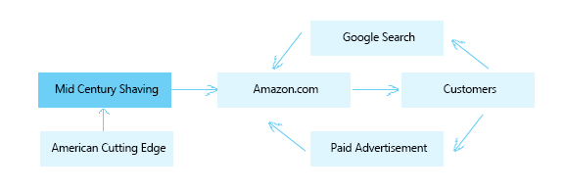

# SUMMARY OF Five-CS

### SWOT Analysis

#### Strengths

* Being an online business model, there is a 24/7 operation running with no time limit on the customer to buy the product.
* A study conducted by ComScore reported 78% of the United States population shops online
* Amazon is the primary channel through which the product reaches the consumer. The logistics is hassle-free and effective.
* The brand is not limited to a geographic area. The products are currently shipped to the whole of North America with the primary focus on the United States.
* Fast delivery ensures that the products are delivered customers don’t lose interest.
* Since the operation cost is low, this can make marketing more affordable through various channels like Facebook, Instagram and google AdWords.
* The company currently doesn’t have any employee except the occasional freelancers hired to assist in marketing and designing.
* All the financial transactions are done online. Hence it is fast and effective.

#### Weakness

* The target segment is focused only on men.
* The CRM is difficult as there is no direct customer-seller interaction.
* Many prefer buying personal grooming products through stores personally than buying them online.
* The product can be sold only to the tech-savvy people who hold an amazon account. A single channel might not be enough.

#### Opportunities

* In the era of internet marketing and the internet users rapidly increasing, this is the perfect time for online businesses.
* Exclusivity is a luxury. Since the product is available only on amazon, it can be marketed as an advantage.
* There is an increase in trend of people wanting a simple and clean shaving solution. This increases the bandwidth of potential customers.

#### Threats

* Since the market is saturated with brands selling safety razors. Market penetration might take a longer time.
* The users might change their mind as the safety razors have a learning curve and it needs time invested initially.
* Groomed beards can be the next rising trend pushing razors to the backseat.

# Marketing Research

MCS needs to determine the consensus among the men in the United States about single blade, safety razors. The brand is focused on analysing the current trend of razors in use, their drawbacks and use them as a promotional tool to reach audience who will readily switch to the vintage shaving kit. Since the brand is based on an eCommerce model, analysis must also be made on keywords associated, website traffic and search engine optimization.

## The Research plan

An online survey was created through Qualtrics and shared to a group of audience that includes a good mix of gender, age and occupation. Being a male grooming product, separate questionnaire was prepared for male and female gender. The key indicators for men include the age, budget and shaving preferences. The number of blades in their current razor, issues encountered and their willingness to go for the vintage shaving option is assessed. For women, they were evaluated on their preference on men grooming and gifting these products.

To assess the current trend in online businesses, website ranking and traffic, semrush.com was used.

Data collection

A total of 70 responses were recorded. From the secondary data collected:

* More than 52.40% of the population most relate to the Wet shaving when it comes to facial grooming. This is in strong support of the products offered.
* Majority of the survey population, which is 40.45% shave on a bi-weekly basis: 9.5% of the survey population replace the razor blade every shave and 11.9% replace the razor blade every other shave for these people.
* 35.03% of the population of the survey would consider buying vintage products.
* 38.12% of the survey prefer buying shaving supplies online.
* When the population of the survey was asked if they would be interested in a new single blade razor elaborating the advantages of MCS product 47.55% chose “Yes”.
* A classification analysis was conducted, and the potential customer is identified. According to the decision tree plotted, there is a 54% change that a target consumer would change to safety razor

From the online marketing research tool, the following data is collected:

* The total number of visits this year is about 10.8K. There was a steady increase in the traffic of about 4K since last year.
* The bounce rate is 31.89% which is higher than the ideal expected value. This indicates the number of people who don’t follow through the pages to successful checkout.
* 70% of the users look at the MCS products in their desktop.
* Out of the 10.8K visitors, only 2.4K people are direct visitors. The remaining 5.2k are either through search or paid ads.
* The top 5 trending keywords with maximum cost per clicks are safety razors, wet shaving, how to shave with safety razors, wet shaving supplies and single blade safety razors.
* The keywords that attract most traffic are “Wet shaving” with high efficiency and indicates a 60.39% difficulty in market penetration and “Safety Razor” with medium efficiency and a difficulty of 99.43% in market penetration.

Planned CRM efforts

Customer relationship is a main factor that MCS targets to get positive reviews and ratings that will serve as a hook to attract potential customers. It ensures the same by posting quick answers in the forum, resolving customer issues and issuing 100% money back on qualified 30-day returns.

Since there is a learning curve that is associated with the safety razors, MCS works on educating customers with a simple, illustrated How-to guide and getting social media influencers to create instructional videos that can reach consumers to influence them to buy the products.

MCS has frequent discounts and referral programs that helps with brand recommendation among peers and friends through word of mouth.

# Market Concentration Decisions

## Market segmentation

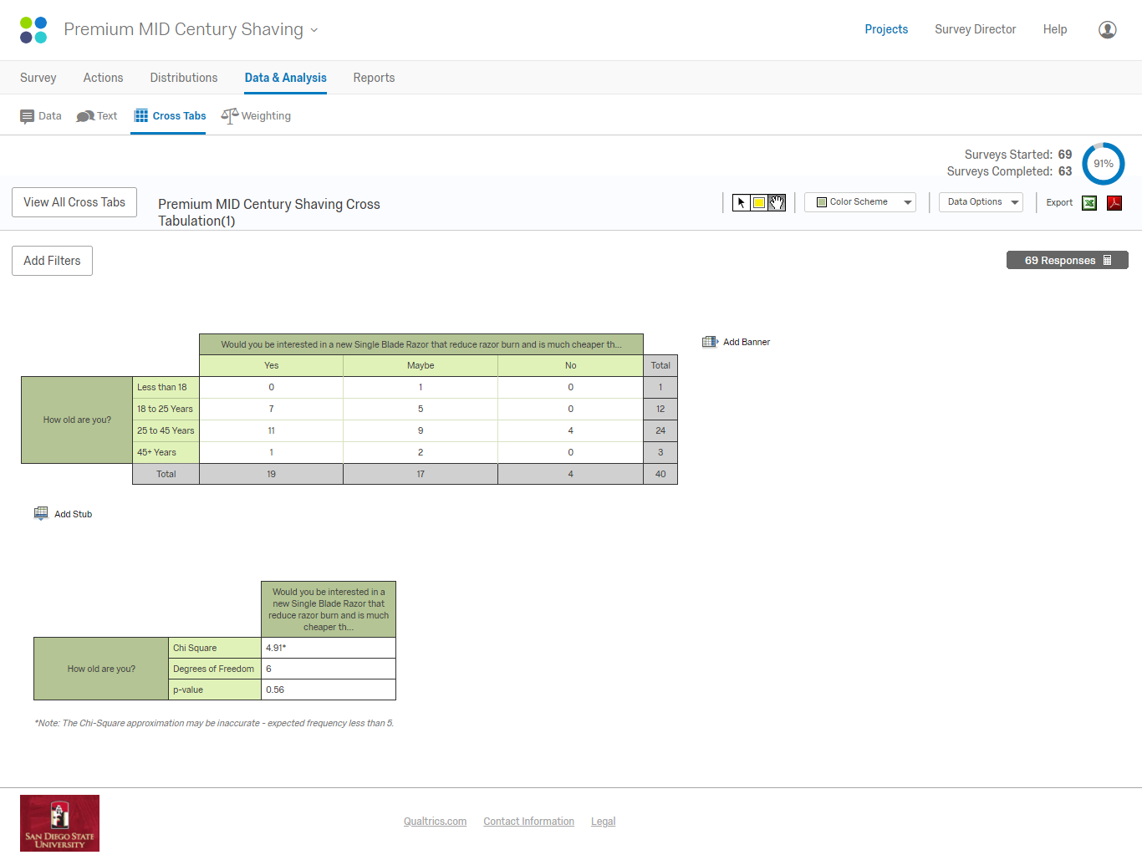MCS is placing itself as a Niche Marketer with focus on the customers in amazon who will fit the profile of “Gentlemen with sharp, clean shaved look”.

Based on the survey, we can understand that the men between the age group 18 to 45 showed interest in the product. They also responded negatively to the cartridge razors that the majority is currently using. From the data collected from our survey, we found that 67% of men are using manual razors that they are not happy with. When conducted a regression analysis, it resulted in a 54% possibility of a person choosing the vintage shaving kit over the manual and electric razors.

MCS targets the consumers available in the USA through amazon. Their main focus will remain on men between 18 and 45 who likes a sauve, clean look as part of their lifestyle. The brand will continue concentrating on acquiring potential first time users as the retention rate is low due to the longer lifecycle of the product. Currenlty MCS has only one product variation in the saftey razors, it is a good fit for beginners who want to try their hands on wet shaving.

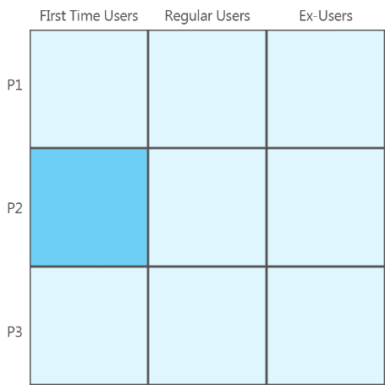

Further market segmentation is possible with increase in product line in the foreseeable future.

## Targeting

The vintage shaving set attracts consumers who likes clean shaves and sharp looks. Considering various factors that outline the company’s interest, the US men between 18 to 60 can fall in one of the target categories:

* **Debonair Businessmen who invests time to look stylish to set the first impression** - They make custom suits that fit them well. A vintage shaving set would be a great addition to set them apart.
* **Investment Bankers with the sophistication to make strong personality marks -** They always look sharp and are persistent to get new clients every day. A close and relaxed shave can give them the uplift they need to start the day
* **Corporate Employees who are poised and dress the right way to the right occasion** - These dynamic people look sharp and the perfect, simple and effective shave is what exactly they need to complete their look
* **Urbane Millennials who are changing the perception of work** - While dressed more casually, they take personal grooming seriously. A well-groomed look is complete with a clean shave that is a comeback trend of using vintage shaving set

Since the company’s current main channel is amazon.com, the target consumer have to be computer savvy and has affinity to shop online. These potential consumers have a college education and is interested on the current style trends on lifestyle, grooming, social media and travel. This classic, vintage shaving kit can also be identified as a characteristic of men who enjoy craft beer and are likely to be a whisky/cigar aficionado.

From market analysis and the survey, the target customer profiles that are of interests are:

1. Young Professionals between the age group18 to 25 looking at efficient clean shaving options
2. Married men from 25 to 45 with a steady income between $60K to $150K per annum i.e. people falling in the mid-income bracket

Positioning

### Value Proposition

A CLASSIC, VINTAGE SHAVING KIT THAT OFFERS A LIFETIME OF RELAXING, CLOSE SHAVE EXPERIENCE.

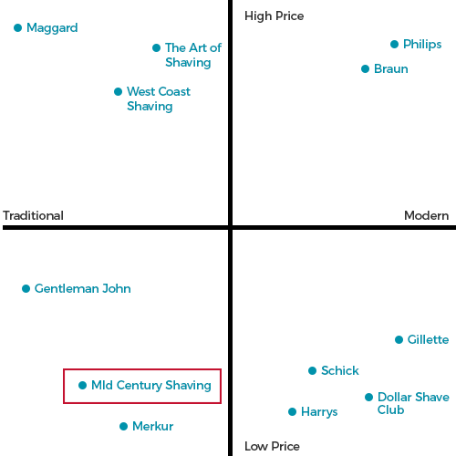

Positioning Statement

To all Married Men looking for a clean, cost-effective shaving solution, Premium Mid-Century Shaving offers shaving experience that bring back the essence of vintage lifestyle of the yesteryears’ grooming, without the hassle of cuts and burns that are synonymous with the Gillette Cartridge razors

To all Young professionals looking to get a suave office look, Premium Mid-Century Shaving offers a masculine, heavy vintage razor that provides a clean, close shave that is precise and smooth, unlike the poor aligned, light weight Merkur Safety Razors

Points of Parity (POP)

Emphasizing in the art of wet shaving, MCS strives at educating the modern men with the vintage shave form that is simple and relaxing, without the hassle of modern technology.

Point of Difference (POD)

Bringing back the vintage grooming style, the shaving kit of MCS is a classic design with aesthetic appeal that provides efficient, close shave possible.

# Marketing Mix Decisions

The following 4Ps are developed to understand and implement the marketing strategy to develop positioning for the target segments.

## Products

The unique selling proposition of the products is their psychological advantage over the other manual and electric razors available in the market that the classic shaving kit is a simple and effective solution to clean, close shave. The brand focuses on beginners who are interested in safety razors.

Premium Mid-Century Shaving offers male grooming products that currently include:

* Double edged Safety razor: The razor is made of double steel and the overall weight of the razor is the same as the popular Gillette Fusion razor.
* Shaving brush: The shaving brush is made of pure Black/Brown 22mm Badger hair with a stylish resin handle.
* Shaving stand: The stainless-steel shaving stand provides a stylish look to the razor and brush, kept in the bathroom
* Shaving cream: With the age of all-natural, chemical free creams in the market, MCS has rolled out organic shaving creams that is free of aerosols.
* Shaving Scuttle: The sturdy ceramic scuttle is used to foam up the shaving cream with the brush.

New product development

MCS being a start-up contains limited product as opposed to the established competitors. MCS is slowly extending its product line by introducing products that are related to shaving and grooming. It launched its inhouse shaving cream on 2016.

* **Increasing the Product line** 
  + Using Premium materials such as wood, stone style vinyl in the razor and brush handle to give the vintage look to the shaving set
  + MCS plans to introduce 5 new shaving cream variations which include: Denim, Citric, Winter Spice, Cider wood and Ocean blue
  + Styling the products for occasions such as Valentine’s Day or Christmas, that will make the products a great vintage gifting option
* **Product Diversification**
  + MCS is planning to introduce a line of after shaves which is a shaving essential that will continue focus on organic ingredients
  + Beard oil is one of the product market competitors are introducing, MCS plans to move in on this market as well, the companies’ expertise with natural/organic materials would be a differential advantage for MCS.
  + Face moisturizers for men is another trending men’s grooming product that MCS is planning to venture into

## Price

While MCS is slowly penetrating the market, the pricing strategy will be based on the competitive pricing since the brand follows an eCommerce model.

|  |  |  |
| --- | --- | --- |
| **Competitor’s Name** | **Competitor’s Razor** | **Price On Amazon** |
| Maggard Razors | Blackland Razors Dart Polished DE Safety Razor | $139 |
| The Art of Shaving | Chrome Heavyweight Safety Razor | $65 |
| Gentleman John | Gentleman Jon Complete Wet Shave Kit | $55 |
| Merkur Solingen | Classic 3-Piece Razor Double Edge Safety Razor | $35 |
| Edwin Jagger | Double Edge Safety Razor Chrome Handle 5 blades | $28 |

MCS wants to price its product in a high value category. From the competitors’ price analysis, a safety razor can range between $20 to $80 for safety razors and the sample data collected through the survey reveals that a significant population are willing to pay $10 to $30 per month on an average. Considering the safety razor is a one-time buy, there is a great ROI for the customer to look forward to.

### Break Even Value

|  |  |
| --- | --- |
| **Fixed Cost** | 11700 |
| **Unit Price** | 23.8 |
| **Unit Variable Cost** | 0 |
| **Break Even Value** | **492** |

The pricing of MCS products are as follows:

1. The complete shaving kit that includes the razor brush and the stand are priced at $27.97 to $59.98, depending on the variants
2. The safety razor is priced at $29.99,
3. The shaving brushes are priced at $19.99 and $34.99 for the two variants,
4. The shaving cream is priced at $21.99 and
5. The scuttle is priced at $49.99.

The margin of profit on a product range between 8% to 20%.

## Promotion

The brand stands out by providing a beginner’s guide to wet shaving when the consumers buy the full kit. The main con of the safety razors is the learning curve before they can be used effectively. MCS is working on breaking the hurdle through blog posts and infographics.

It also runs year-around offers on amazon depending on the season and competitors. A 100% satisfaction guarantee is also provided where the product can be returned if the user is dissatisfied with the product within 30 days. The company also gives a discount for next purchase for those customers who bought the shaving kit, thereby encouraging them to continue purchasing the shaving supplies.

Being an eCommerce store, the main channel for promotion is through Google ads and Facebook ads. The advertisements are based on extensive keyword research.

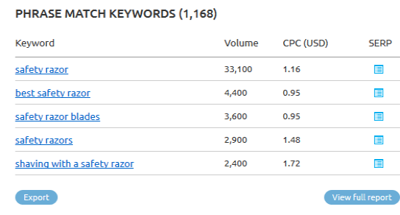

The total revenue earned in the year 2018 through ads is $2736.71. MCS is constantly analysing the web traffic to increase the conversion rate of the customers from 24% to 75% in the next 2 years.

The vintage brand also plans on implementing modern marketing technique of promotion through influencers in media such as Instagram, YouTube and Facebook - who would help promote and educate people on the usage of the safety razor. This will lead to affiliations across various social media platforms and blog posts. The backlinks to MCS products can be a major resource to get clickthrough. This in turn will lead to increased conversion rates in the webpage. The brand adopts to Facebook, Google AdWords and Instagram for its marketing channel

## Placement

MCS products are available across the USA through Amazon. 82% of the revenue for MCS comes from Amazon. MCS chooses to focus on Amazon as the primary channel of sales as a large majority of the targeted audience shop mostly on amazon and MCS products have a high rating, customer appreciation on Amazon review which would influence first time buyers’ decision to choose the products. The remaining 18% comprises of the exclusive channels: Facebook Page and mcshaving.com.



MCS analysed that most of the traffic comes through amazon website. The most common view mode is through desktop. The brand will focus on creating a search engine optimized Website/Sub Pages that will provide the consumers with seamless buying experience.

Furthermore, MCS is planning on analysing the sales data from to determine which regions have the most sales that will open to the possibility of setting up retail shops in popular locations. From the survey, it can be noticed that the sample population preferred going to a retail store to buy their shaving kit.

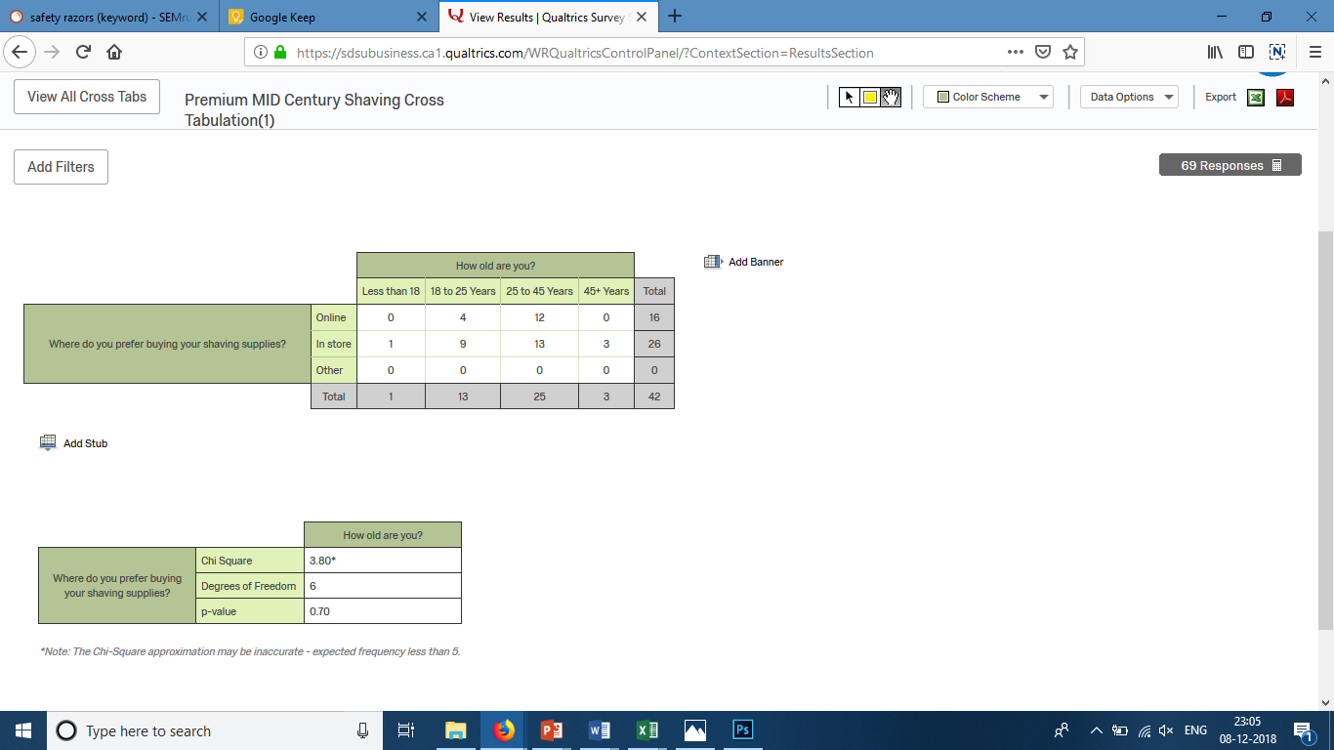

By having retail stores can help expand the market share. It can enable consumers to get their hands on the product prompting them to switch to single blade safety razor. MCS will continue implementing Web analytics to get better insights on its sales channels to boost its sales and profits.

# Conclusion

From our market research, we were able to identify our target segment and the marketing mix. We adopted a range of Key performance indicators to set the goal and assess the success of the marketing plan.

* Market Share – The company projects a minimum of 40% increase in the market share by the end of year 5.
* Overall Sales – There is a steady increase in the revenue through the last 5 years. The brand will continue to assess and reiterate the marketing budget on online ads to increase the conversion rate by at least 50% and decrease the bounce rate to less than 10%
* Brand Rating – Being an online store with its primary channel as amazon, the company strives at maintaining its reputation through customer reviews and rating. It will focus on a 100% increase in the number of review and rating that will reinforce the brand image
* Product Innovation – With its new line of shaving cream launched in 2016, the company plans on expanding to new variations and other wet shaving products. The company plans on rolling out 3 products every year to check the audience acceptance as beta test followed by full production the consecutive year

The marketing plan will be re-evaluated every year to check if it has met the overall target. There will be iterations using the past performance and forecast data to improvise the marketing strategy. This is to take advantage of the changing trend, company’s strength and brand awareness over the period.

## Budgets and Forecasts

On average, MCS annual budget is $42,786 out of which about 8% is dedicated to online advertising. In 2018, a total of $6600 is dedicated to the ads in Facebook and Google Search. The brand has passed through the breakeven point well before the second year with the sale of 492 units. We forecast that there will be a threefold increase in the number of customers of up to 5000 in the next 5 years projecting a Total revenue of $ 149950. The budget for marketing will double to 16% as well.

## APPENDIX

#### 1.1 Feasibility Report

|  |  |  |  |  |  |  |  |  |  |  |  |  |
| --- | --- | --- | --- | --- | --- | --- | --- | --- | --- | --- | --- | --- |
|  | **2014** | **2015** | | | **2016** | | **2017** | | **2018** | | **Total** | |
|  |  |  | | |  | |  | |  | |  | |
| **Sales** |  | 13245 | | | 30288 | | 45761 | | 48883.28 | | 138178 | |
| **Revenue generated Through Ad** |  | 200 | | | 424 | | 1248 | | 2736.72 | | 4608 | |
| **Total Revenue** |  | 13445 | | | 30712 | | 47009 | | 51620 | | 142786 | |
| **PV Total Revenue** |  | 12449 | | | 26331 | | 37317 | | 37942 | | **116749** | |
|  |  |  | | |  | |  | |  | |  | |
|  |  |  | | |  | |  | |  | |  | |
| **Setting up Cost** | 11000 |  | | |  | |  | |  | | 11000 | |
| **Incorporation Fee** | 200 |  | | |  | |  | |  | | 200 | |
| **Market Research** | 500 |  | | |  | |  | |  | | 500 | |
| **Capital** | 11700 |  | | |  | |  | |  | | 11700 | |
|  |  |  | | |  | |  | |  | |  | |
| **Operating Cost** |  |  | | |  | |  | |  | | 0 | |
| **Website/Online Management Cost** |  | 120 | | | 120 | | 120 | | 120 | | 120 | |
| **Procurement cost** |  | 11097 | | | 21330 | | 36089 | | 40554 | | 109070 | |
| **Maintenance agreement for server** |  | 50 | | | 50 | | 50 | | 50 | | 200 | |
| **Insurance** |  | 1200 | | | 1200 | | 1200 | | 1200 | | 4800 | |
| **Marketing** |  | 2500 | | | 2000 | | 4000 | | 6600 | | 15100 | |
| **Total Expenditure** |  | 14967 | | | 24700 | | 41459 | | 48524 | | 129650 | |
|  |  |  | | |  | |  | |  | |  | |
| **Total Costs** | 11700 | 14967 | | | 24700 | | 41459 | | 48524 | | 141350 | |
| **Total Benefits - Total Costs** | -11700 | -1522 | | | 6012 | | 5550 | | 3096 | | 1436 | |
| **PV Total Cost** | 11700 | 13858 | | | 21176 | | 32911 | | 35667 | | **115313** | |
| **Return of Investment** | 1.015918 | % | | |  | |  | |  | |  | |
| **Break Even Point** | 1.536176 | Years | | |  | |  | |  | |  | |
|  |  |  | | |  | |  | |  | |  | |
| **Net Present Value** | 1436 |  | | |  | |  | |  | |  | |
| **Fixed Cost** | 11700 | |
| **Unit Price** | 23.8 | |
| **Variable Cost** | 0 | |
| **Break Even Value** | 492 | |
| **No. Of Years** | 5 | | |  | |  | |  | |  | |  | |
| **Gross Margin (percentage)** | 11% | | |  | |  | |  | |  | |  | |
| **Monthly gross margin (percentage)** | 11% | | |  | |  | |  | |  | |  | |
| **Retention and Acquisition Rate** | 4% | | |  | |  | |  | |  | |  | |
| **Customer Lifetime Value** | 161.1 | | |  | |  | |  | |  | |  | |
| 1.2 Break Even Point |  | | |  | |  | |  | |  | |  | |

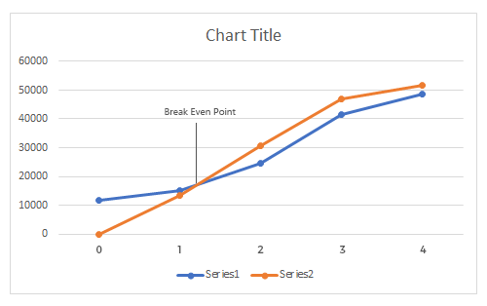

#### 1.3 2018 Ad Expenditure

GOOGLE ADS

|  |  |  |  |  |
| --- | --- | --- | --- | --- |
| **Keyword** | | **Keyword Difficulty Index** | **Cost Per Click** | **Average # of searches Per Month** |
| **Wet Shaving** | 58.94 | | 3.05 | 55.5M |
| **Wet Shaving Products** | 58.1 | | 1.66 | 1.6M |
| **Wet Shaving Supplies** | 65.15 | | 3.81 | 37.9M |
| **How to Wet shave** | 62.47 | | 3.8 | 32.81M |
| **How to shave with a safety razor** | 70.97 | | 3.18 | 8.7M |
| **Safety Razor** | 66.05 | | 1.16 | 3.3M |
| **Double Edge Safety Razor** | 55.68 | | 0.99 | 7.8M |
| **How to use a safety razor** | 65.69 | | 4.59 | 40.2M |
| **Single Blade Safety Razor** | 74.61 | | 1.33 | 8.3M |
| **Safety Razor Amazon** | 99.43 | | 0.49 | 0.8M |
|  |  | | **Monthly** | **Yearly** |
|  | **Total Cost** | | 24.06 | 288.72 |
|  | **Ad Spent** | | 400 | 4800 |
|  | **Estimated Clicks** | | 16.62 | 199.50 |
|  | **Conversion Ratee** | | 24% | 24% |
|  | **No. of Customers Acquired** | | 3.998 | 47.88 |
|  | **Average Sales per Customer** | | 35.69 | 428.28 |
|  | **Total Revenue Through** | | 142.40 | 1708.85 |
|  |  | |  |  |
|  |  | |  |  |
|  |  | |  |  |
| FACEBOOK ADS |  | |  |  |
| **Targeting Keyword** | **Potential Reach** | | **Estimated Reach** | **Conversions** |
| **Safety Razor** | 1.1M | | 190 | 53 |
| **Shaving** | 40M | | 510 | 9 |
|  |  | | **Monthly** | **Yearly** |
|  | **Total Cost** | | 15 | 180 |
|  | **Ad Spent** | | 150 | 1800 |
|  | **Estimated Clicks** | | 10 | 120 |
|  | **Conversion Rate** | | 24% | 24% |
|  | **No. of Customers Acquired** | | 2.4 | 28.8 |
|  | **Average Sales per Customer** | | 35.69 | 428.28 |
|  | **Total Revenue Through** | | 85.656 | 1027.872 |
|  |  | |  |  |
|  |  | |  |  |
|  | **Total Cost Spent on Ad** | | 6600 |  |
|  | **Total Revenue generated Through Ad** | | 2736.71 |  |

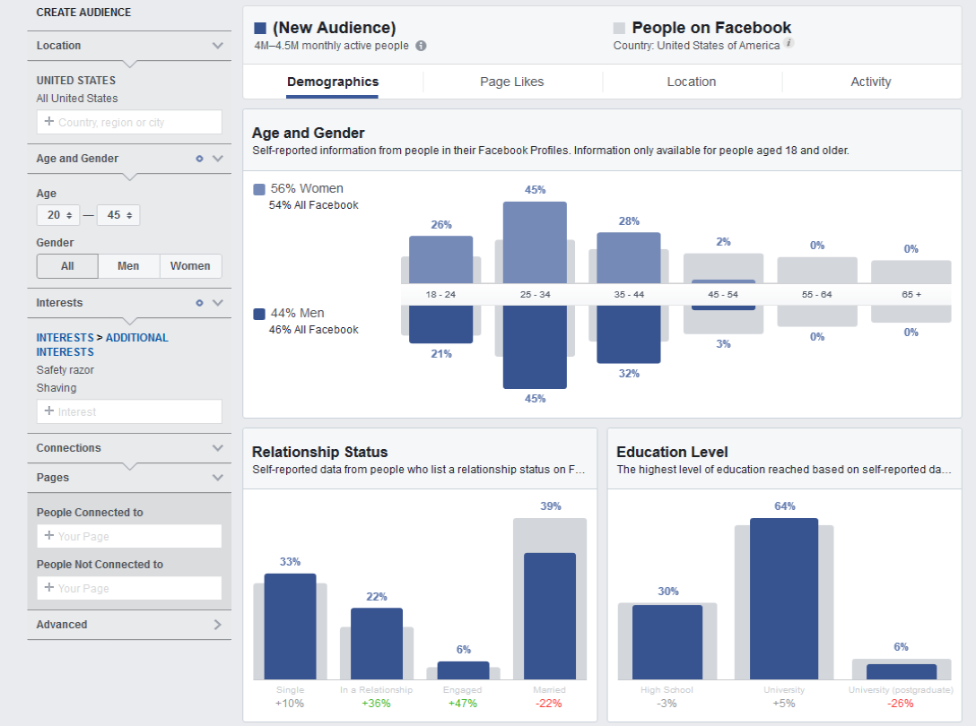

*1.4 Keyword Mapping*

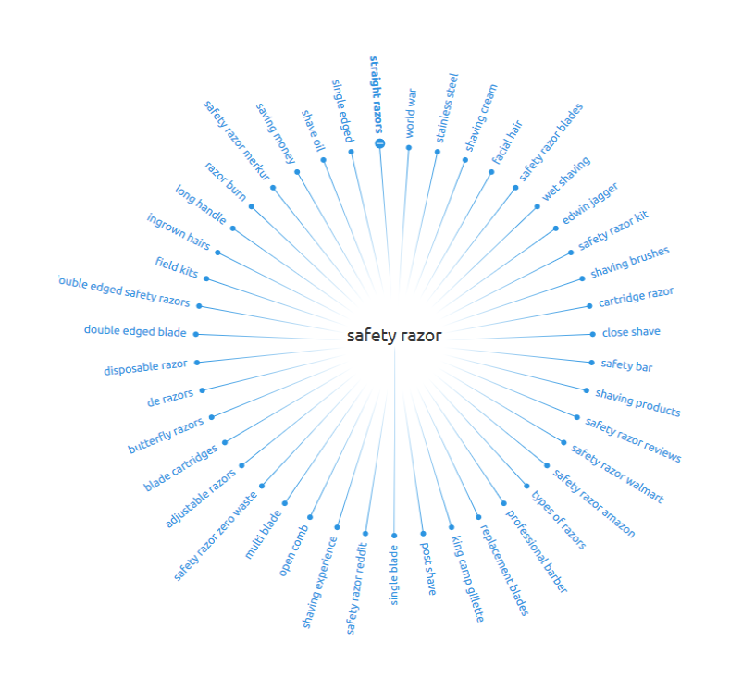

*1.5 Sales Through Amazon*

|  |  |  |  |  |  |  |  |
| --- | --- | --- | --- | --- | --- | --- | --- |
| **Year** | **Order method type** | **Quantity Sold** | **Avg. Unit cost** | **Unit Selling price** | **Product cost** | **Revenue** | **Gross profit** |
| 2014-2015 | Amazon | 448 | 25.68 | 29.99 | 11512.48 | 13444.68 | 1932.20 |
| 2015-2016 | Amazon | 1024 | 24.65 | 29.99 | 14374.58 | 30711.56 | 16336.98 |
| 2016-2017 | Amazon | 1567 | 24 | 29.99 | 21925.19 | 47009.13 | 25083.94 |
| 2017-2018 | Amazon | 1721 | 23.8 | 29.99 | 24820.46 | 51619.96 | 26799.50 |

*1.6 Survey Questions*

1. What is your Gender?
2. How old are you?
3. How many blades your Razor have?
4. What type of Razor you prefer to use?
5. How would you describe your grooming preference?
6. How much do you spend on personal Grooming in a month?
7. How many times a month do you Shave?
8. What do you think is the main problems encountered with Shaving?
9. What shaving accessories you use?
10. How likely are you to take you shaving kit while you travel?
11. When you shave, your Priority is:
12. What process of shaving you most relate with?
13. What Brand and model of Razor do you use?
14. How often do you replace the Razor Blades?
15. Where do you prefer buying your shaving supplies?
16. Please rank the Following attributes you consider while buying a Razor.(1 as important and 5 as not important)
17. Would you buy a Razor for Gifting Purpose?
18. Would you be interested in a new Single Blade Razor that reduce razor burn and is much cheaper than leading brands for quality replacement blades?
19. If yes, how much how much would you be expecting to pay for this Razor?
20. How long have you owned your current Razor?

*1.7 Website Traffic Analysis*

#### 

#### 1.8 Regression Analysis

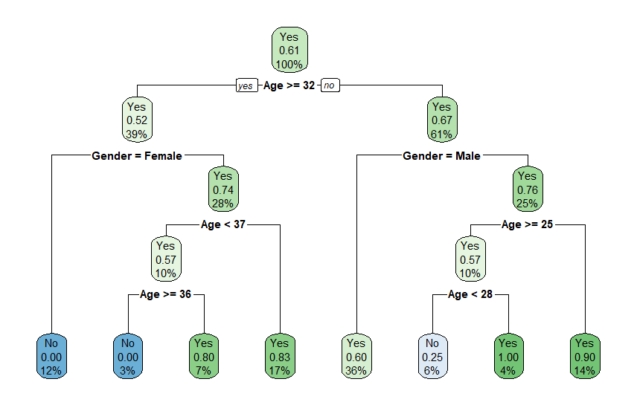

*1.9 Illustrations*

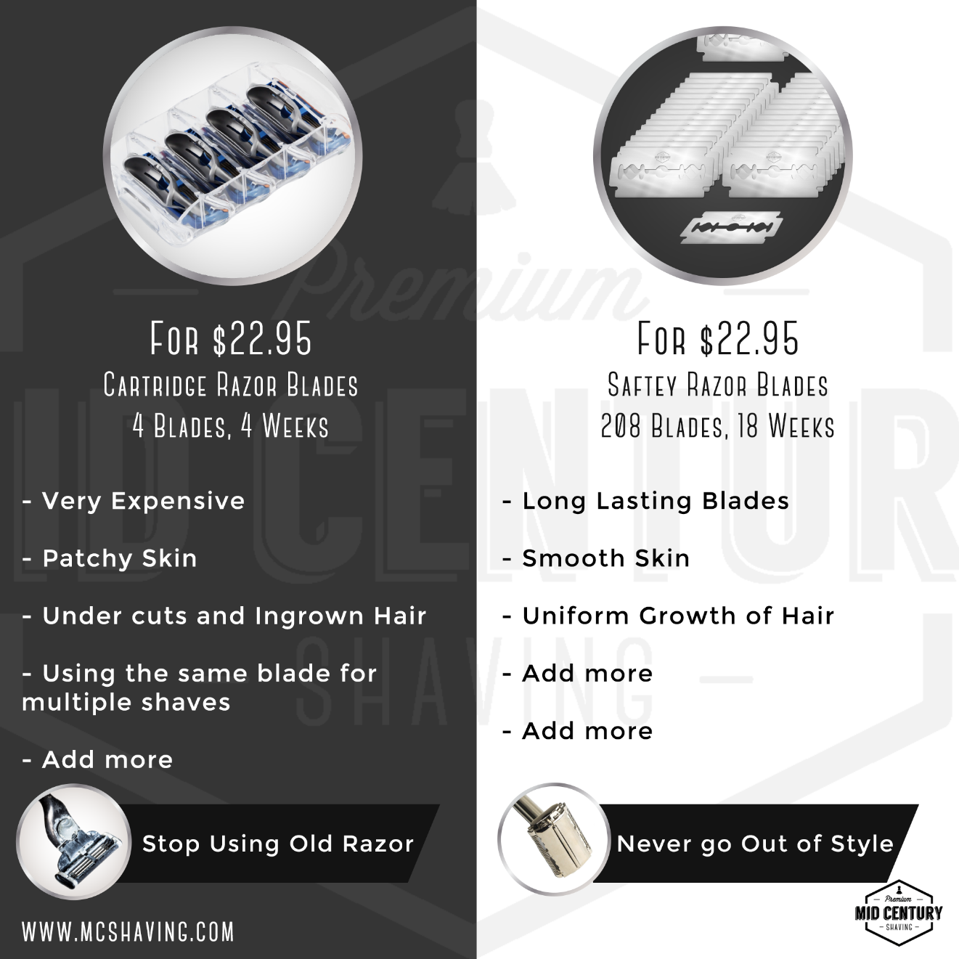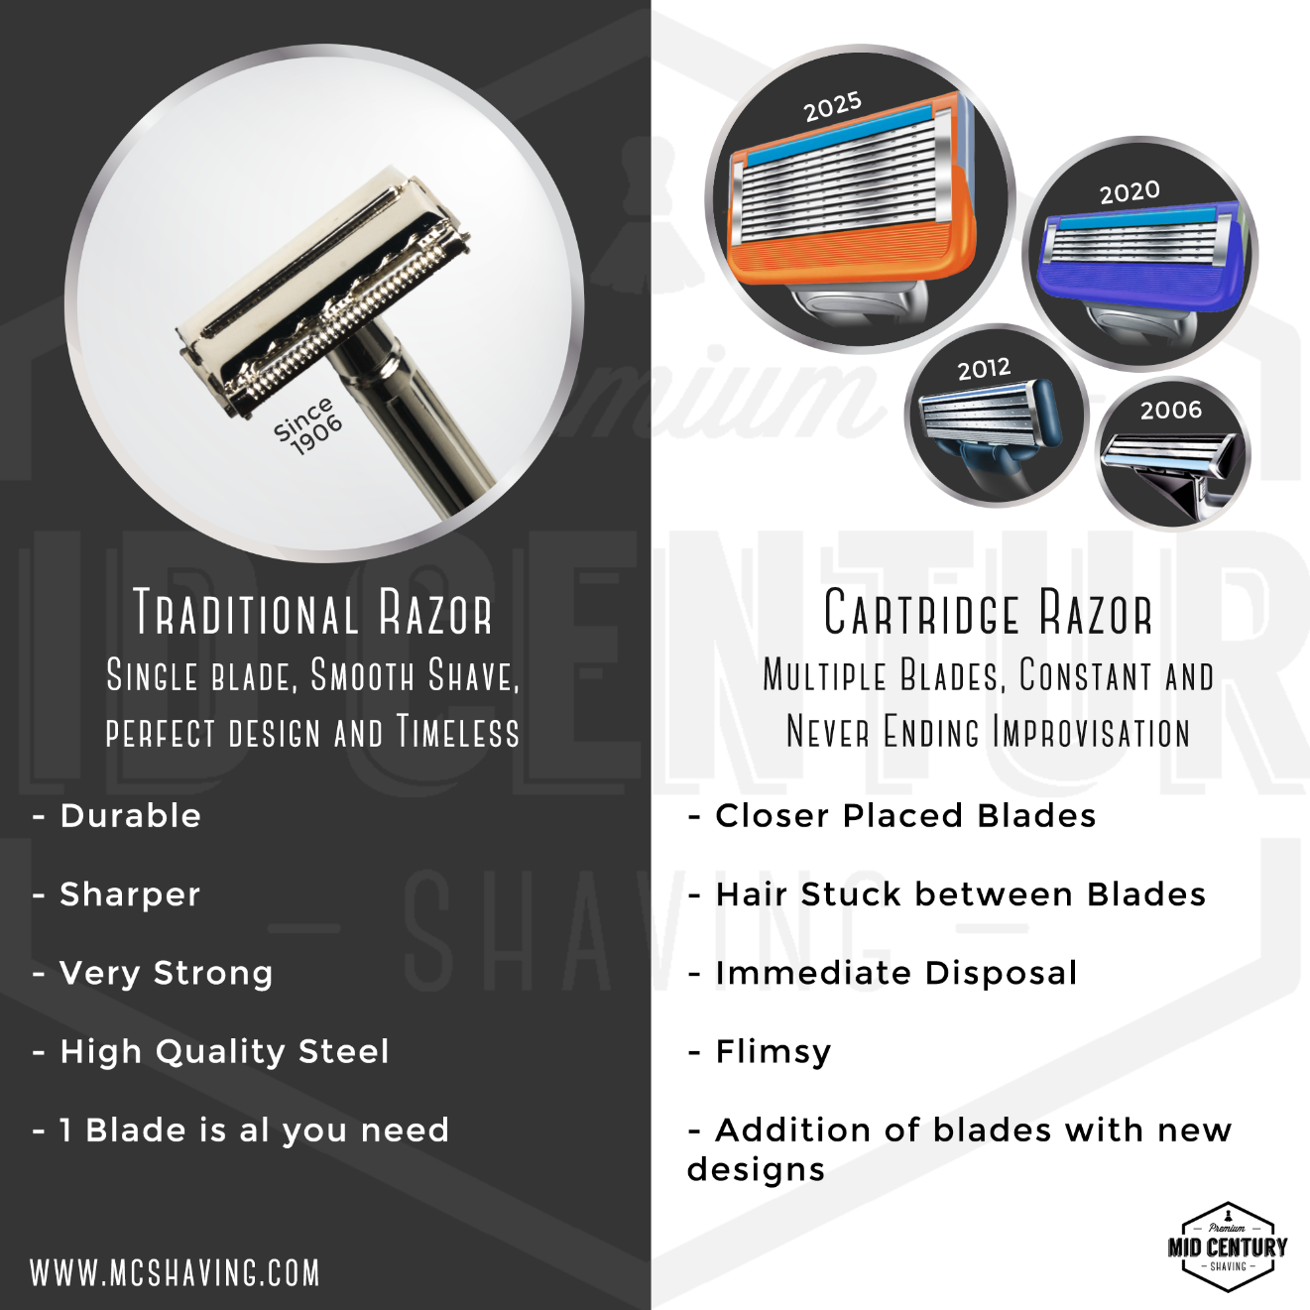

#### 2.0 Resources

https://www.facebook.com/ads/audience-insights/

https://analytics.google.com/analytics/web/

https://www.semrush.com/info/

https://www.bluebeards-revenge.co.uk/blog/a-long-shave-men-spend-45-days-of-their-lives-shaving/

https://www.ultimatepersonalshaver.com/tips-and-how-to-26-75-fun-facts-and-myths-about-shaving

https://www.realmenrealstyle.com/5-razor-types/

https://www.creditdonkey.com/shaving-statistics.html